Hive Assignment – 01 solution

1. Download vechile sales data -> https://github.com/shashank-mishra219/Hive-Class/blob/main/sales_order_data.csv

2. Store raw data into hdfs location

3. Create a internal hive table "sales_order_csv" which will store csv data sales_order_csv .. make sure to skip header row while creating table

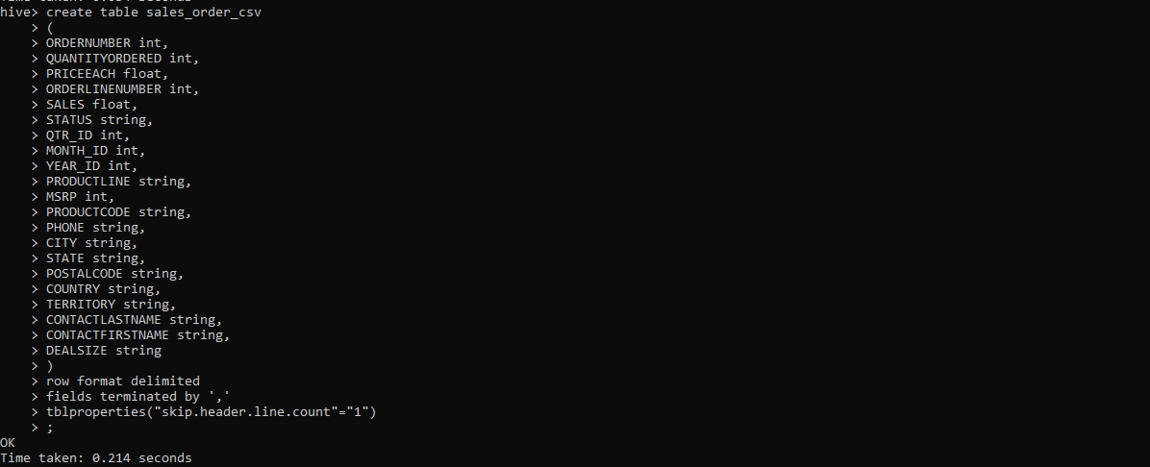

4. Load data from hdfs path into "sales_order_csv"

LOAD DATA LOCAL INPATH '/home/sales_order_data.csv' INTO TABLE sales_order_csv;

5. Create an internal hive table which will store data in ORC format "sales_order_orc"

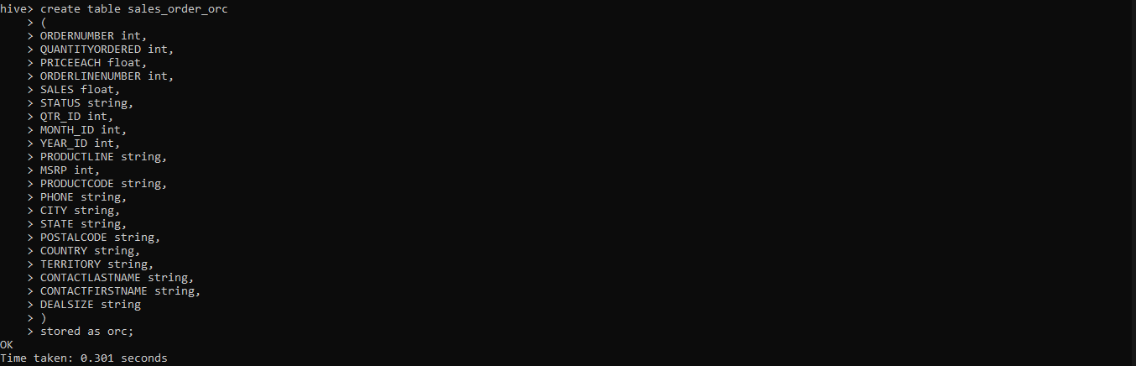

6. Load data from "sales_order_csv" into "sales_order_orc"

* from sales_order_csv insert overwrite table sales_order_orc select *;

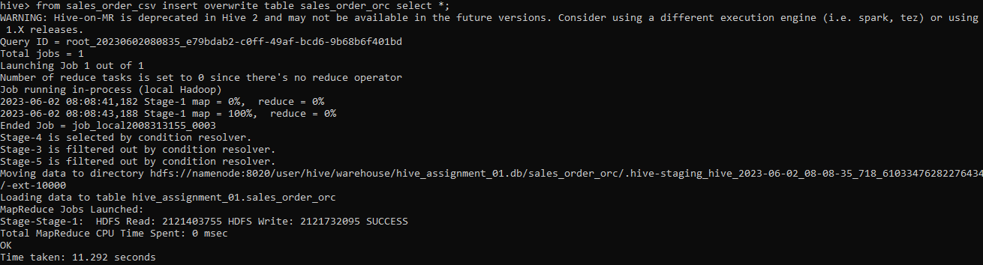

Perform below menioned queries on "sales_order_orc" table :

1. Calculate total sales per year
   * select year_id as year,sum(sales) as total_sales_per_year

from sales_order_orc

group by year_id;

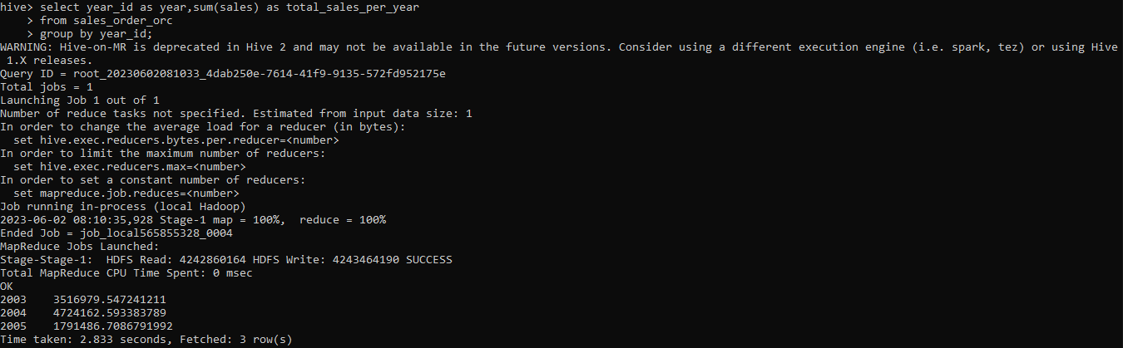

1. Find a product for which maximum orders were placed

* select sum(quantityordered) as total_qantity,productline as max_order_product

from sales_order_orc

group by productline

order by total_qantity desc

limit 1;

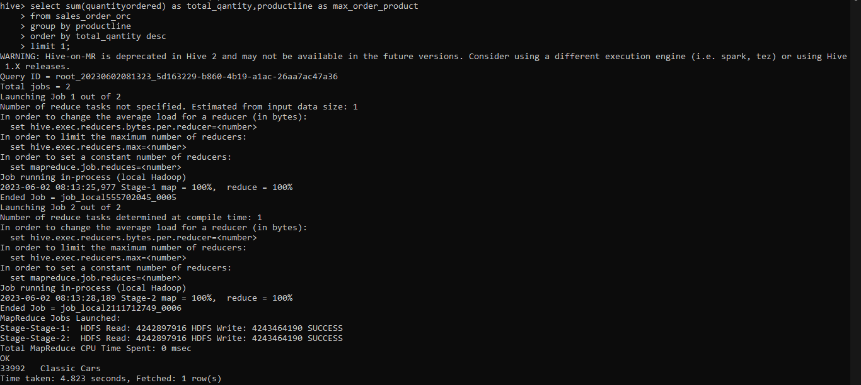

c. Calculate the total sales for each quarter

* select sum(sales) as total_sales_each_quarter,qtr_id as quarter

from sales_order_orc

group by qtr_id;

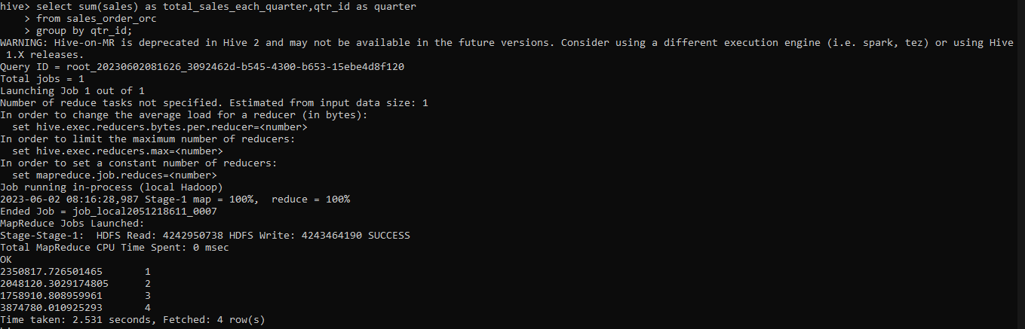

d. In which quarter sales was minimum

* select sum(sales) as total_sales,qtr_id as quarter

from sales_order_orc

group by qtr_id

order by total_sales

limit 1;

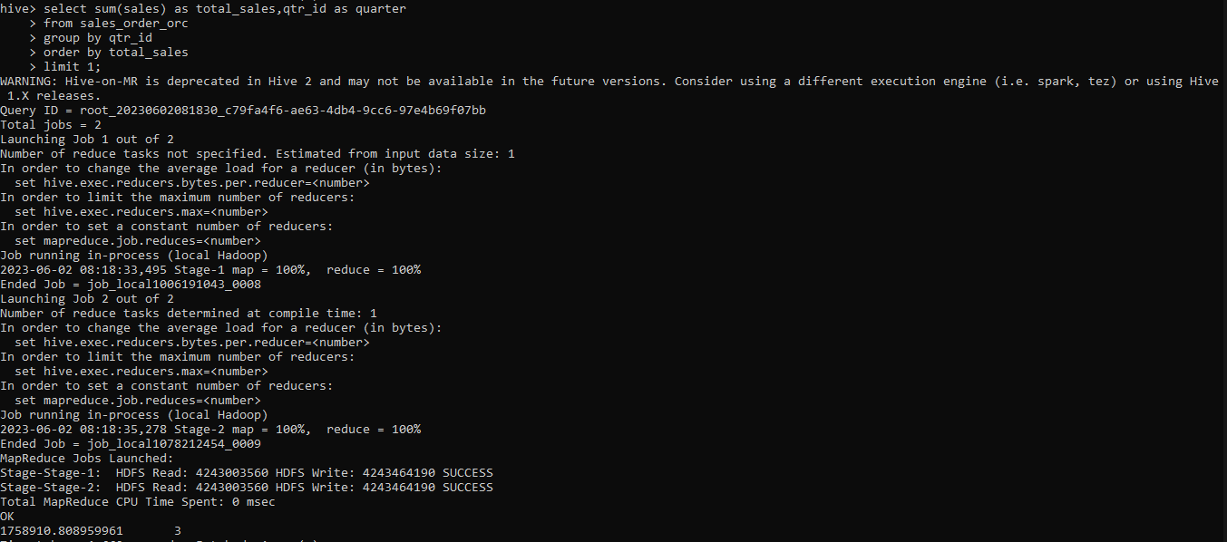

e. In which country sales was maximum and in which country sales was minimum

* (select sum(sales) as total_sales,country from sales_order_orc group by country order by total_sales limit 1)

union all

select sum(sales) as total_sales,country from sales_order_orc group by country order by total_sales desc limit 1;

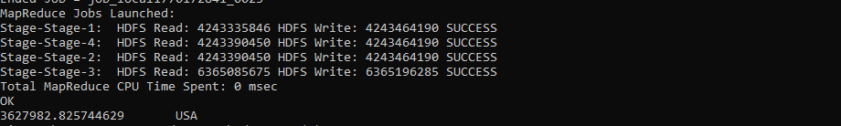

f. Calculate quarterly sales for each city

* select city,quarter,sum(sales) as total_sales
* from
* (select city, case
* when month_id >3 and month_id < 7 then "quater_2"
* when month_id >6 and month_id < 10 then 'quater_3'
* when month_id >9 and month_id <13 then 'quater_4'
* else 'quater1'
* end as quarter,
* sales
* from sales_order_orc
* ) t1
* group by city, quarter
* order by city, quarter;

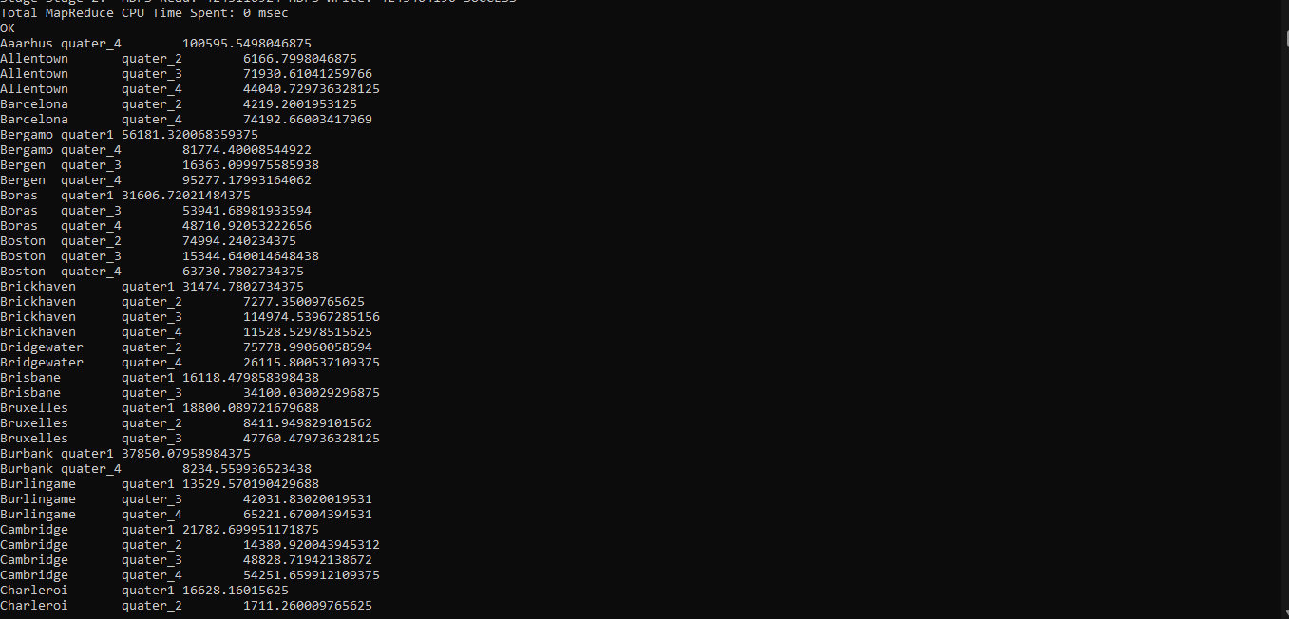

h. Find a month for each year in which maximum number of quantities were sold.

* select year_id,
* month_id,
* total_sales
* from
* ( select year_id,
* month_id,
* total_sales,dense_rank() over (partition by year_id order by total_sales desc) as ranks
* from ( select year_id,
* month_id,
* sum(sales) as total_sales
* from sales_order_orc
* group by year_id,
* month_id
* ) table1
* ) table2
* where ranks = 1;

